*Lab 20: STP - Bridges, RPs, DPs, etc*

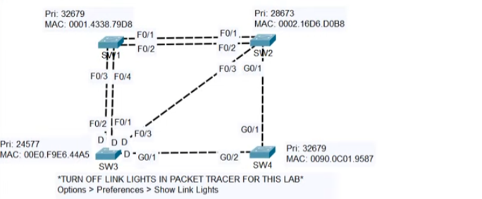

When finding Root Ports

Look at this:



How do we know which port will be root from SW3 to SW1?

1. Check path cost - same for both interfaces, as they can either go long way around for 27 cost, or straight to SW3 (root bridge) for 19.
2. Then, we check neighbour bridge ID for these SW1 interfaces, but neighbour for both is SW3
3. Then, we check neighbour switch’s port ID (so for F0/3, we look at F0/2 and for F0/4 we check F0/1)

F0/1 is lower than F0/2 so F0/4 is the RP